Lab Report No 5

Implementation of Image Histogram and Equalization
Digital Image Processing



Submitted By:
[Huzaifa Shahbaz]
[21-CE-009]
[Aqsa Shah]
[21-CE-039]

Submitted to:
Engr. Hareem Khan
Dated:
25thOct,2024

Department of Computer Engineering,
HITEC University, Taxila
Lab Example No 1:

Solution:
Brief description (3-5 lines)
An image histogram is a visual representation of the tonal distribution in a digital image, plotting the number of pixels for each tonal value, allowing viewers to quickly understand the entire tonal distribution in a specific image.
The code
import cv2
import numpy as np
import matplotlib.pyplot as plt
# Load the image in grayscale
image = cv2.imread('download.jpeg', 0)
# Calculate the histogram using numpy.histogram()
# 'bins=256' means we want 256 intensity levels (for grayscale images, 0 to 255)
# 'range=(0, 256)' means we are considering pixel intensities in this range
hist, bin_edges = np.histogram(image, bins=256, range=(0, 256))
#histogram = cv2.calcHist([image], [0], None, [256], [0, 256])
# Plot the histogram
plt.plot(bin_edges[0:-1], hist)
plt.title('Image Histogram')
plt.xlabel('Pixel Intensity')
plt.ylabel('Frequency')
plt.show()
The results (Screenshot)
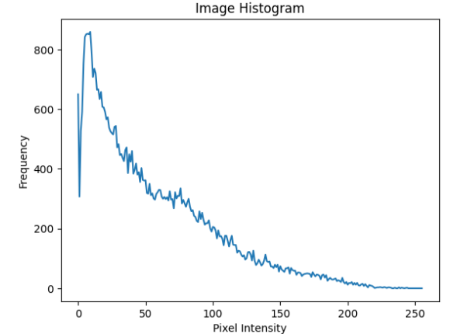

Lab Example No 2:

Solution:
Brief description (3-5 lines)
Histogram equalization:
Histogram of an image shows the frequency of different intensities values present in the image.
This gives a clear idea of what intensities dominate the image. Histogram equalization is a
technique that uses this information to enhance the contrast using the probability of a certain pixel
to occur. The Image obtained will be Histogram Equalized Image with high contrast.
The code
import cv2
import numpy as np
import matplotlib.pyplot as plt
# Load the image in grayscale
image = cv2.imread('download.jpeg', 0)
# Perform Histogram Equalization
equalized_image = cv2.equalizeHist(image)
# Calculate the histogram of the equalized image
equalized_histogram = cv2.calcHist([equalized_image], [0], None, [256], [0,
256])
# Display the original and equalized image side by side
plt.subplot(2, 2, 1)
plt.imshow(image, cmap='gray')
plt.title('Original Image')
plt.subplot(2, 2, 2)
plt.plot('histogram')
plt.title('Original Histogram')
plt.subplot(2, 2, 3)
plt.imshow(equalized_image, cmap='gray')
plt.title('Equalized Image')
plt.subplot(2, 2, 4)
plt.plot(equalized_histogram)
plt.title('Equalized Histogram')
plt.show()
The results (Screenshot)
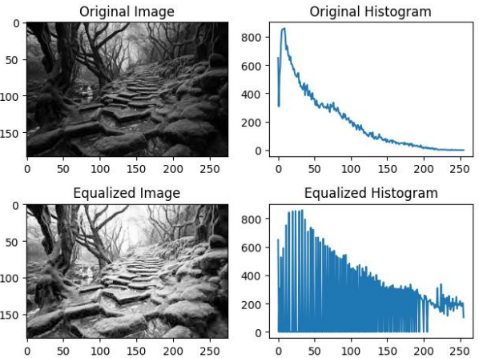
Lab Task No 1:

Solution:
Brief description (3-5 lines)
Apply Histogram equalization on the given image by applying above steps.
i. Calculate the histogram of the image save it as Figure_1.jpg.
ii. Calculate probability density function (PDF) from the histogram and save it as
Figure_2.jpg. PDF = H/(R*C). Where H is the Histogram and R and C is the
number of Rows and Columns of the image respectively.
iii. Calculate cumulative density function (CDF) and save it as Figure_3.jpg.
iv. Multiply the Cumulative PDF with 255 to find the transformation function then save it as Figure_4.jpg
v. From the transformation function, replace the gray levels of the image to create
contrast enhanced (histogram equalized) image and save it as Figure_5.jpg
vi. Calculate the histogram of the output image save it as Figure_6.jpg.
The code
import cv2
import numpy as np
import matplotlib.pyplot as plt
# Load the image
image = cv2.imread("image.jpg", cv2.IMREAD_GRAYSCALE)
# Calculate the histogram of the image
hist, bins = np.histogram(image.flatten(), 256, [0, 256])
# Save the histogram as Figure_1.jpg
plt.figure()
plt.hist(image.flatten(), 256, [0, 256])
plt.title("Histogram of the Image")
plt.xlabel("Pixel Intensity")
plt.ylabel("Frequency")
plt.savefig("Figure_1.jpg")
# Calculate the probability density function (PDF)
rows, cols = image.shape
pdf = hist / (rows * cols)
# Save the PDF as Figure_2.jpg
plt.figure()
plt.plot(pdf)
plt.title("Probability Density Function")
plt.xlabel("Pixel Intensity")
plt.ylabel("Probability")
plt.savefig("Figure_2.jpg")
# Calculate the cumulative density function (CDF)
cdf = np.cumsum(pdf)
# Save the CDF as Figure_3.jpg
plt.figure()
plt.plot(cdf)
plt.title("Cumulative Density Function")
plt.xlabel("Pixel Intensity")
plt.ylabel("Cumulative Probability")
plt.savefig("Figure_3.jpg")
# Multiply the Cumulative PDF with 255 to find the transformation function
transform_function = cdf * 255
# Save the transformation function as Figure_4.jpg
plt.figure()
plt.plot(transform_function)
plt.title("Transformation Function")
plt.xlabel("Pixel Intensity")
plt.ylabel("Output Intensity")
plt.savefig("Figure_4.jpg")
# Apply the transformation function to the image
equalized_image = np.uint8(np.interp(image.flatten(), np.arange(256), transform_function))
equalized_image = np.reshape(equalized_image, image.shape)
# Save the contrast enhanced image as Figure_5.jpg
cv2.imwrite("Figure_5.jpg", equalized_image)
# Calculate the histogram of the output image
hist, bins = np.histogram (equalized_image.flatten(), 256, [0, 256])
# Save the histogram of the output image as Figure_6.jpg
plt.figure()
plt.hist(equalized_image.flatten(), 256, [0, 256])
plt.title("Histogram of the Equalized Image")
plt.xlabel("Pixel Intensity")
plt.ylabel("Frequency")
plt.savefig("Figure_6.jpg")
The results (Screenshot)
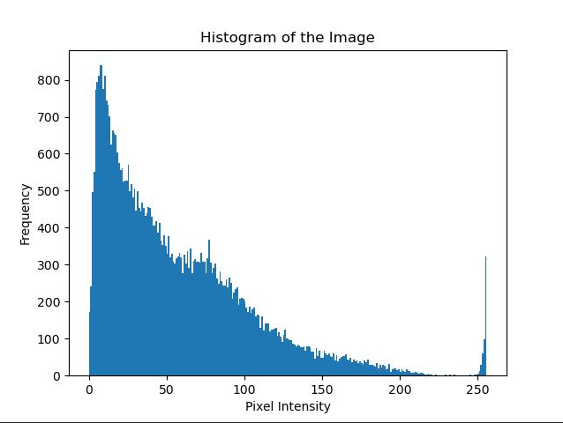
FIGURE 1
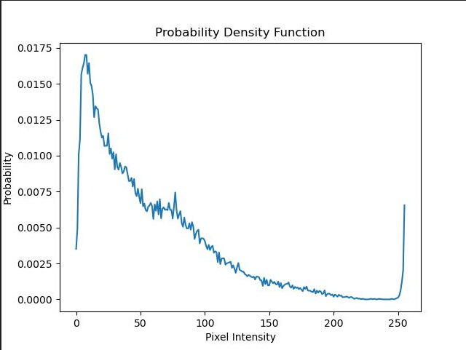
FIGURE 2
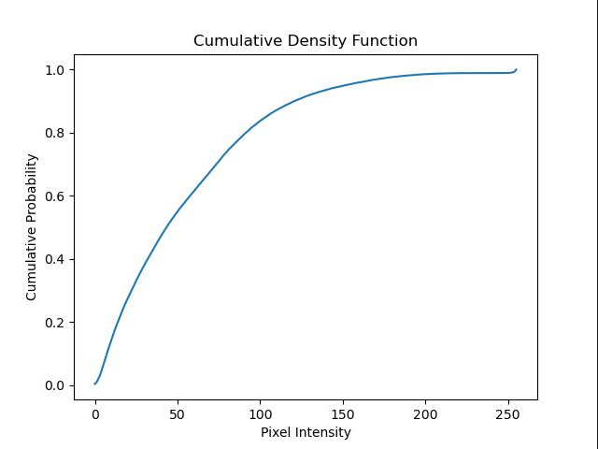
FIGURE 3
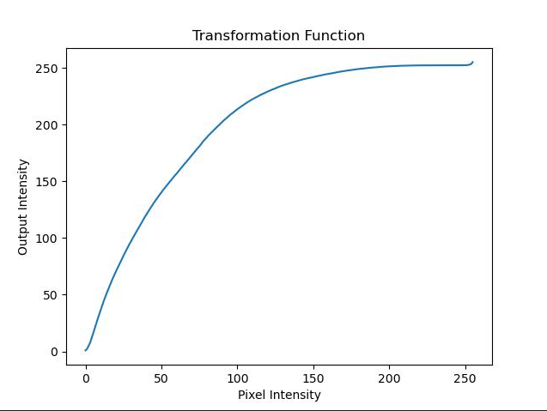
FIGURE 4
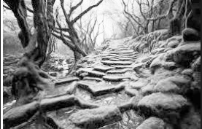
FIGURE 5
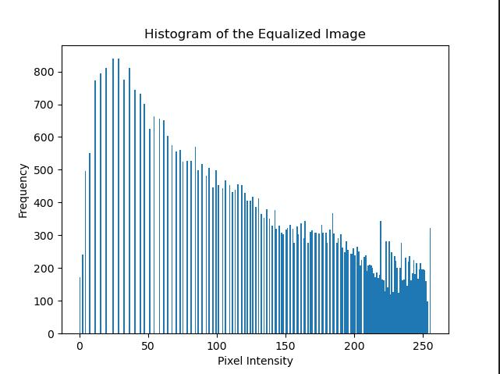
FIGURE 6
Lab Task No 2:

Solution:
Brief description (3-5 lines)
For the given image
i. Calculate histogram of the given image using build-in functions of numpy or OpenCV.
ii. Calculate histogram equalization of the given image using build-in functions of numpy
or OpenCV and display your output.
The code
import cv2
import numpy as np
import matplotlib.pyplot as plt
# Load the image
img = cv2.imread('Screenshot 2024-10-25 103016.jpg')
# Convert to grayscale
gray_img = cv2.cvtColor(img, cv2.COLOR_BGR2GRAY)
# Calculate the histogram
hist = cv2.calcHist([gray_img], [0], None, [256], [0, 256])
# Calculate histogram equalization
equalized_img = cv2.equalizeHist(gray_img)
# Display the original and equalized images
plt.subplot(1, 2, 1)
plt.imshow(gray_img, cmap='gray')
plt.title('Original Image')
plt.subplot(1, 2, 2)
plt.imshow(equalized_img, cmap='gray')
plt.title('Equalized Image')
plt.show()
The results (Screenshot)
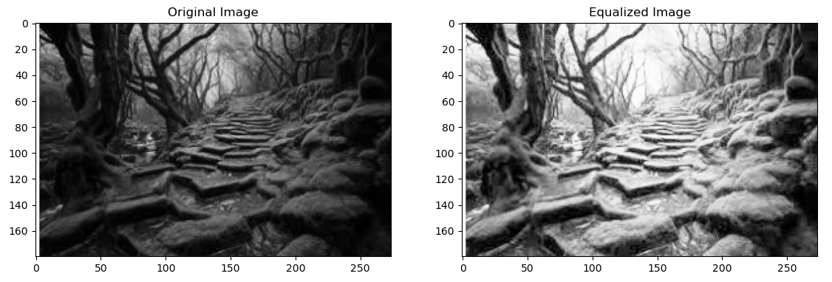
Conclusion
In conclusion, Image histogram and equalization improve image quality by enhancing contrast and brightness levels. This technique, particularly beneficial in low-contrast images, enhances detail visibility. Histogram equalization is computationally efficient, making it suitable for real-time applications. Its effectiveness is demonstrated in medical imaging, remote sensing, and photography, demonstrating its potential in various imaging fields.

